Индивидуальное задание 4

Задание 1

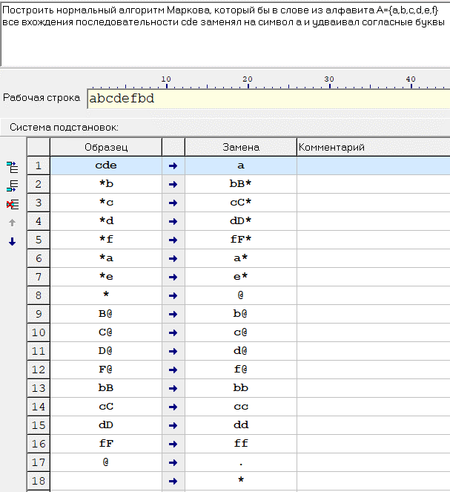

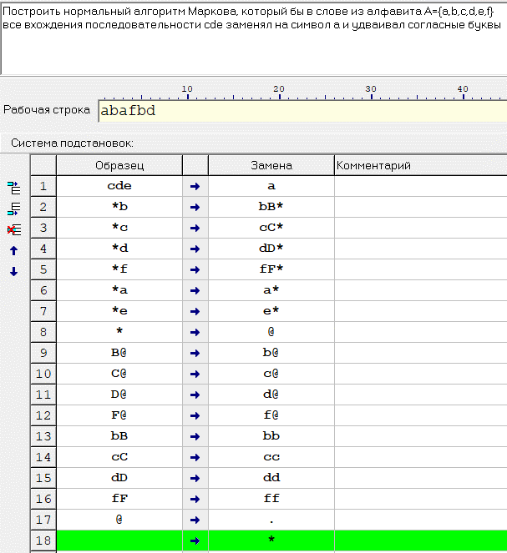























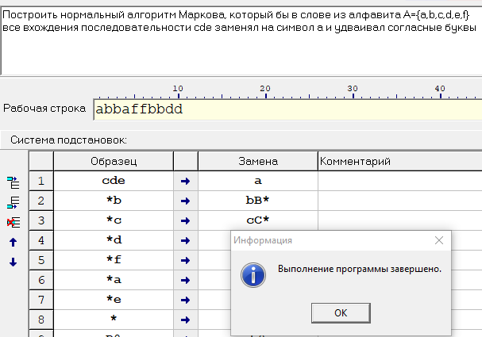

Задание 2

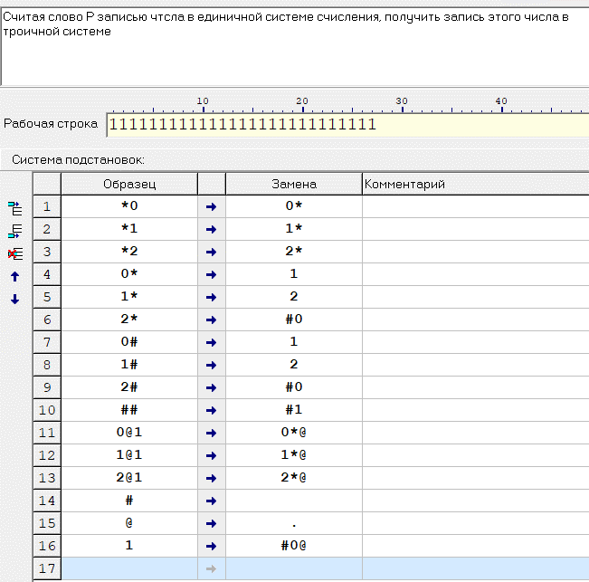











Индивидуальное задание 5

Построить машину с неограниченными регистрами, вычисляющую функцию y(х)=ax

|  |  |
| --- | --- |
| S(1) | Использовано 7 ячеек  В r2 находится a  В r6 находится x  В r1 по окончанию программы находится ответ |
| J(6, 7, 19) |
| J(1, 3, 14) |
| J(2, 3, 13) |
| T(1, 3) |
| S(5) |
| J(2, 5, 13) |
| Z(4) |
| S(3) |
| S(4) |
| J(1, 4, 6) |
| J(1, 1, 9) |
| T(3, 1) |
| Z(3) |
| Z(4) |
| Z(5) |
| S(7) |
| J(0,0,2) |
| Z(2) |
| Z(6) |
| Z(7) |

Пример выполнения программы для y = 43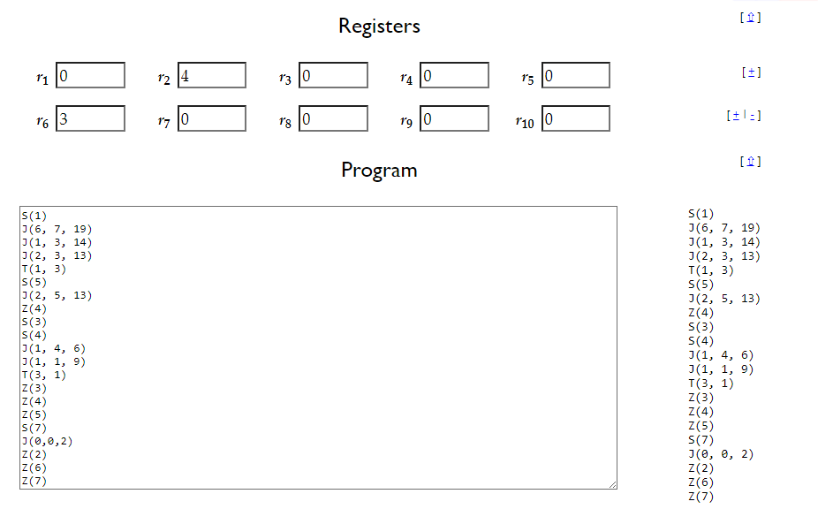

Instruction r_1 r_2 r_3 r_4 r_5 r_6 r_7 r_8 r_9 r_10

1 0 4 0 0 0 3 0 0 0 0

2 1 4 0 0 0 3 0 0 0 0

3 1 4 0 0 0 3 0 0 0 0

4 1 4 0 0 0 3 0 0 0 0

5 1 4 0 0 0 3 0 0 0 0

6 1 4 1 0 0 3 0 0 0 0

7 1 4 1 0 1 3 0 0 0 0

8 1 4 1 0 1 3 0 0 0 0

9 1 4 1 0 1 3 0 0 0 0

10 1 4 2 0 1 3 0 0 0 0

11 1 4 2 1 1 3 0 0 0 0

6 1 4 2 1 1 3 0 0 0 0

7 1 4 2 1 2 3 0 0 0 0

8 1 4 2 1 2 3 0 0 0 0

9 1 4 2 0 2 3 0 0 0 0

10 1 4 3 0 2 3 0 0 0 0

11 1 4 3 1 2 3 0 0 0 0

6 1 4 3 1 2 3 0 0 0 0

7 1 4 3 1 3 3 0 0 0 0

8 1 4 3 1 3 3 0 0 0 0

9 1 4 3 0 3 3 0 0 0 0

10 1 4 4 0 3 3 0 0 0 0

11 1 4 4 1 3 3 0 0 0 0

6 1 4 4 1 3 3 0 0 0 0

7 1 4 4 1 4 3 0 0 0 0

13 1 4 4 1 4 3 0 0 0 0

14 4 4 4 1 4 3 0 0 0 0

15 4 4 0 1 4 3 0 0 0 0

16 4 4 0 0 4 3 0 0 0 0

17 4 4 0 0 0 3 0 0 0 0

18 4 4 0 0 0 3 1 0 0 0

2 4 4 0 0 0 3 1 0 0 0

3 4 4 0 0 0 3 1 0 0 0

4 4 4 0 0 0 3 1 0 0 0

5 4 4 0 0 0 3 1 0 0 0

6 4 4 4 0 0 3 1 0 0 0

7 4 4 4 0 1 3 1 0 0 0

8 4 4 4 0 1 3 1 0 0 0

9 4 4 4 0 1 3 1 0 0 0

10 4 4 5 0 1 3 1 0 0 0

11 4 4 5 1 1 3 1 0 0 0

12 4 4 5 1 1 3 1 0 0 0

9 4 4 5 1 1 3 1 0 0 0

10 4 4 6 1 1 3 1 0 0 0

11 4 4 6 2 1 3 1 0 0 0

12 4 4 6 2 1 3 1 0 0 0

9 4 4 6 2 1 3 1 0 0 0

10 4 4 7 2 1 3 1 0 0 0

11 4 4 7 3 1 3 1 0 0 0

12 4 4 7 3 1 3 1 0 0 0

9 4 4 7 3 1 3 1 0 0 0

10 4 4 8 3 1 3 1 0 0 0

11 4 4 8 4 1 3 1 0 0 0

6 4 4 8 4 1 3 1 0 0 0

7 4 4 8 4 2 3 1 0 0 0

8 4 4 8 4 2 3 1 0 0 0

9 4 4 8 0 2 3 1 0 0 0

10 4 4 9 0 2 3 1 0 0 0

11 4 4 9 1 2 3 1 0 0 0

12 4 4 9 1 2 3 1 0 0 0

9 4 4 9 1 2 3 1 0 0 0

10 4 4 10 1 2 3 1 0 0 0

11 4 4 10 2 2 3 1 0 0 0

12 4 4 10 2 2 3 1 0 0 0

9 4 4 10 2 2 3 1 0 0 0

10 4 4 11 2 2 3 1 0 0 0

11 4 4 11 3 2 3 1 0 0 0

12 4 4 11 3 2 3 1 0 0 0

9 4 4 11 3 2 3 1 0 0 0

10 4 4 12 3 2 3 1 0 0 0

11 4 4 12 4 2 3 1 0 0 0

6 4 4 12 4 2 3 1 0 0 0

7 4 4 12 4 3 3 1 0 0 0

8 4 4 12 4 3 3 1 0 0 0

9 4 4 12 0 3 3 1 0 0 0

10 4 4 13 0 3 3 1 0 0 0

11 4 4 13 1 3 3 1 0 0 0

12 4 4 13 1 3 3 1 0 0 0

9 4 4 13 1 3 3 1 0 0 0

10 4 4 14 1 3 3 1 0 0 0

11 4 4 14 2 3 3 1 0 0 0

12 4 4 14 2 3 3 1 0 0 0

9 4 4 14 2 3 3 1 0 0 0

10 4 4 15 2 3 3 1 0 0 0

11 4 4 15 3 3 3 1 0 0 0

12 4 4 15 3 3 3 1 0 0 0

9 4 4 15 3 3 3 1 0 0 0

10 4 4 16 3 3 3 1 0 0 0

11 4 4 16 4 3 3 1 0 0 0

6 4 4 16 4 3 3 1 0 0 0

7 4 4 16 4 4 3 1 0 0 0

13 4 4 16 4 4 3 1 0 0 0

14 16 4 16 4 4 3 1 0 0 0

15 16 4 0 4 4 3 1 0 0 0

16 16 4 0 0 4 3 1 0 0 0

17 16 4 0 0 0 3 1 0 0 0

18 16 4 0 0 0 3 2 0 0 0

2 16 4 0 0 0 3 2 0 0 0

3 16 4 0 0 0 3 2 0 0 0

4 16 4 0 0 0 3 2 0 0 0

5 16 4 0 0 0 3 2 0 0 0

6 16 4 16 0 0 3 2 0 0 0

7 16 4 16 0 1 3 2 0 0 0

8 16 4 16 0 1 3 2 0 0 0

9 16 4 16 0 1 3 2 0 0 0

10 16 4 17 0 1 3 2 0 0 0

11 16 4 17 1 1 3 2 0 0 0

12 16 4 17 1 1 3 2 0 0 0

9 16 4 17 1 1 3 2 0 0 0

10 16 4 18 1 1 3 2 0 0 0

11 16 4 18 2 1 3 2 0 0 0

12 16 4 18 2 1 3 2 0 0 0

9 16 4 18 2 1 3 2 0 0 0

10 16 4 19 2 1 3 2 0 0 0

11 16 4 19 3 1 3 2 0 0 0

12 16 4 19 3 1 3 2 0 0 0

9 16 4 19 3 1 3 2 0 0 0

10 16 4 20 3 1 3 2 0 0 0

11 16 4 20 4 1 3 2 0 0 0

12 16 4 20 4 1 3 2 0 0 0

9 16 4 20 4 1 3 2 0 0 0

10 16 4 21 4 1 3 2 0 0 0

11 16 4 21 5 1 3 2 0 0 0

12 16 4 21 5 1 3 2 0 0 0

9 16 4 21 5 1 3 2 0 0 0

10 16 4 22 5 1 3 2 0 0 0

11 16 4 22 6 1 3 2 0 0 0

12 16 4 22 6 1 3 2 0 0 0

9 16 4 22 6 1 3 2 0 0 0

10 16 4 23 6 1 3 2 0 0 0

11 16 4 23 7 1 3 2 0 0 0

12 16 4 23 7 1 3 2 0 0 0

9 16 4 23 7 1 3 2 0 0 0

10 16 4 24 7 1 3 2 0 0 0

11 16 4 24 8 1 3 2 0 0 0

12 16 4 24 8 1 3 2 0 0 0

9 16 4 24 8 1 3 2 0 0 0

10 16 4 25 8 1 3 2 0 0 0

11 16 4 25 9 1 3 2 0 0 0

12 16 4 25 9 1 3 2 0 0 0

9 16 4 25 9 1 3 2 0 0 0

10 16 4 26 9 1 3 2 0 0 0

11 16 4 26 10 1 3 2 0 0 0

12 16 4 26 10 1 3 2 0 0 0

9 16 4 26 10 1 3 2 0 0 0

10 16 4 27 10 1 3 2 0 0 0

11 16 4 27 11 1 3 2 0 0 0

12 16 4 27 11 1 3 2 0 0 0

9 16 4 27 11 1 3 2 0 0 0

10 16 4 28 11 1 3 2 0 0 0

11 16 4 28 12 1 3 2 0 0 0

12 16 4 28 12 1 3 2 0 0 0

9 16 4 28 12 1 3 2 0 0 0

10 16 4 29 12 1 3 2 0 0 0

11 16 4 29 13 1 3 2 0 0 0

12 16 4 29 13 1 3 2 0 0 0

9 16 4 29 13 1 3 2 0 0 0

10 16 4 30 13 1 3 2 0 0 0

11 16 4 30 14 1 3 2 0 0 0

12 16 4 30 14 1 3 2 0 0 0

9 16 4 30 14 1 3 2 0 0 0

10 16 4 31 14 1 3 2 0 0 0

11 16 4 31 15 1 3 2 0 0 0

12 16 4 31 15 1 3 2 0 0 0

9 16 4 31 15 1 3 2 0 0 0

10 16 4 32 15 1 3 2 0 0 0

11 16 4 32 16 1 3 2 0 0 0

6 16 4 32 16 1 3 2 0 0 0

7 16 4 32 16 2 3 2 0 0 0

8 16 4 32 16 2 3 2 0 0 0

9 16 4 32 0 2 3 2 0 0 0

10 16 4 33 0 2 3 2 0 0 0

11 16 4 33 1 2 3 2 0 0 0

12 16 4 33 1 2 3 2 0 0 0

9 16 4 33 1 2 3 2 0 0 0

10 16 4 34 1 2 3 2 0 0 0

11 16 4 34 2 2 3 2 0 0 0

12 16 4 34 2 2 3 2 0 0 0

9 16 4 34 2 2 3 2 0 0 0

10 16 4 35 2 2 3 2 0 0 0

11 16 4 35 3 2 3 2 0 0 0

12 16 4 35 3 2 3 2 0 0 0

9 16 4 35 3 2 3 2 0 0 0

10 16 4 36 3 2 3 2 0 0 0

11 16 4 36 4 2 3 2 0 0 0

12 16 4 36 4 2 3 2 0 0 0

9 16 4 36 4 2 3 2 0 0 0

10 16 4 37 4 2 3 2 0 0 0

11 16 4 37 5 2 3 2 0 0 0

12 16 4 37 5 2 3 2 0 0 0

9 16 4 37 5 2 3 2 0 0 0

10 16 4 38 5 2 3 2 0 0 0

11 16 4 38 6 2 3 2 0 0 0

12 16 4 38 6 2 3 2 0 0 0

9 16 4 38 6 2 3 2 0 0 0

10 16 4 39 6 2 3 2 0 0 0

11 16 4 39 7 2 3 2 0 0 0

12 16 4 39 7 2 3 2 0 0 0

9 16 4 39 7 2 3 2 0 0 0

10 16 4 40 7 2 3 2 0 0 0

11 16 4 40 8 2 3 2 0 0 0

12 16 4 40 8 2 3 2 0 0 0

9 16 4 40 8 2 3 2 0 0 0

10 16 4 41 8 2 3 2 0 0 0

11 16 4 41 9 2 3 2 0 0 0

12 16 4 41 9 2 3 2 0 0 0

9 16 4 41 9 2 3 2 0 0 0

10 16 4 42 9 2 3 2 0 0 0

11 16 4 42 10 2 3 2 0 0 0

12 16 4 42 10 2 3 2 0 0 0

9 16 4 42 10 2 3 2 0 0 0

10 16 4 43 10 2 3 2 0 0 0

11 16 4 43 11 2 3 2 0 0 0

12 16 4 43 11 2 3 2 0 0 0

9 16 4 43 11 2 3 2 0 0 0

10 16 4 44 11 2 3 2 0 0 0

11 16 4 44 12 2 3 2 0 0 0

12 16 4 44 12 2 3 2 0 0 0

9 16 4 44 12 2 3 2 0 0 0

10 16 4 45 12 2 3 2 0 0 0

11 16 4 45 13 2 3 2 0 0 0

12 16 4 45 13 2 3 2 0 0 0

9 16 4 45 13 2 3 2 0 0 0

10 16 4 46 13 2 3 2 0 0 0

11 16 4 46 14 2 3 2 0 0 0

12 16 4 46 14 2 3 2 0 0 0

9 16 4 46 14 2 3 2 0 0 0

10 16 4 47 14 2 3 2 0 0 0

11 16 4 47 15 2 3 2 0 0 0

12 16 4 47 15 2 3 2 0 0 0

9 16 4 47 15 2 3 2 0 0 0

10 16 4 48 15 2 3 2 0 0 0

11 16 4 48 16 2 3 2 0 0 0

6 16 4 48 16 2 3 2 0 0 0

7 16 4 48 16 3 3 2 0 0 0

8 16 4 48 16 3 3 2 0 0 0

9 16 4 48 0 3 3 2 0 0 0

10 16 4 49 0 3 3 2 0 0 0

11 16 4 49 1 3 3 2 0 0 0

12 16 4 49 1 3 3 2 0 0 0

9 16 4 49 1 3 3 2 0 0 0

10 16 4 50 1 3 3 2 0 0 0

11 16 4 50 2 3 3 2 0 0 0

12 16 4 50 2 3 3 2 0 0 0

9 16 4 50 2 3 3 2 0 0 0

10 16 4 51 2 3 3 2 0 0 0

11 16 4 51 3 3 3 2 0 0 0

12 16 4 51 3 3 3 2 0 0 0

9 16 4 51 3 3 3 2 0 0 0

10 16 4 52 3 3 3 2 0 0 0

11 16 4 52 4 3 3 2 0 0 0

12 16 4 52 4 3 3 2 0 0 0

9 16 4 52 4 3 3 2 0 0 0

10 16 4 53 4 3 3 2 0 0 0

11 16 4 53 5 3 3 2 0 0 0

12 16 4 53 5 3 3 2 0 0 0

9 16 4 53 5 3 3 2 0 0 0

10 16 4 54 5 3 3 2 0 0 0

11 16 4 54 6 3 3 2 0 0 0

12 16 4 54 6 3 3 2 0 0 0

9 16 4 54 6 3 3 2 0 0 0

10 16 4 55 6 3 3 2 0 0 0

11 16 4 55 7 3 3 2 0 0 0

12 16 4 55 7 3 3 2 0 0 0

9 16 4 55 7 3 3 2 0 0 0

10 16 4 56 7 3 3 2 0 0 0

11 16 4 56 8 3 3 2 0 0 0

12 16 4 56 8 3 3 2 0 0 0

9 16 4 56 8 3 3 2 0 0 0

10 16 4 57 8 3 3 2 0 0 0

11 16 4 57 9 3 3 2 0 0 0

12 16 4 57 9 3 3 2 0 0 0

9 16 4 57 9 3 3 2 0 0 0

10 16 4 58 9 3 3 2 0 0 0

11 16 4 58 10 3 3 2 0 0 0

12 16 4 58 10 3 3 2 0 0 0

9 16 4 58 10 3 3 2 0 0 0

10 16 4 59 10 3 3 2 0 0 0

11 16 4 59 11 3 3 2 0 0 0

12 16 4 59 11 3 3 2 0 0 0

9 16 4 59 11 3 3 2 0 0 0

10 16 4 60 11 3 3 2 0 0 0

11 16 4 60 12 3 3 2 0 0 0

12 16 4 60 12 3 3 2 0 0 0

9 16 4 60 12 3 3 2 0 0 0

10 16 4 61 12 3 3 2 0 0 0

11 16 4 61 13 3 3 2 0 0 0

12 16 4 61 13 3 3 2 0 0 0

9 16 4 61 13 3 3 2 0 0 0

10 16 4 62 13 3 3 2 0 0 0

11 16 4 62 14 3 3 2 0 0 0

12 16 4 62 14 3 3 2 0 0 0

9 16 4 62 14 3 3 2 0 0 0

10 16 4 63 14 3 3 2 0 0 0

11 16 4 63 15 3 3 2 0 0 0

12 16 4 63 15 3 3 2 0 0 0

9 16 4 63 15 3 3 2 0 0 0

10 16 4 64 15 3 3 2 0 0 0

11 16 4 64 16 3 3 2 0 0 0

6 16 4 64 16 3 3 2 0 0 0

7 16 4 64 16 4 3 2 0 0 0

13 16 4 64 16 4 3 2 0 0 0

14 64 4 64 16 4 3 2 0 0 0

15 64 4 0 16 4 3 2 0 0 0

16 64 4 0 0 4 3 2 0 0 0

17 64 4 0 0 0 3 2 0 0 0

18 64 4 0 0 0 3 3 0 0 0

2 64 4 0 0 0 3 3 0 0 0

19 64 4 0 0 0 3 3 0 0 0

20 64 0 0 0 0 3 3 0 0 0

21 64 0 0 0 0 0 3 0 0 0

STOP 64 0 0 0 0 0 0 0 0 0

Задание 2

F(x)=x/2

J(1,3,6)

S(3)

S(3)

S(2)

J(0,0,1)

T(2,1)

